**Lectura comprensiva**

**Nombre: Grado:**

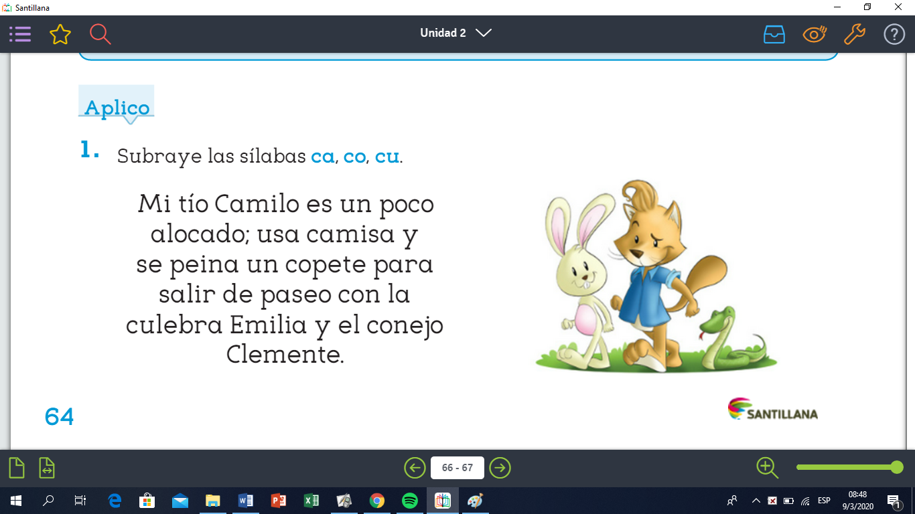

**Responde:**

1. ¿Cómo es Camilo?

________________________________________________________________________________________________________________________________________________________________________________________________________________________________________________________________________________________________________

1. ¿Quién es Emilia?

________________________________________________________________________________________________________________________________________________________________________________________________________________________________________________________________________________________________________

1. ¿Cómo se llama el conejo?

________________________________________________________________________________________________________________________________________________________________________________________________________________________________________________________________________________________________________

**Escribe verdadero (V) o falso (F)**

Camilo es mi vecino.

El conejo Clemente usa camisa.

Emilia, Clemente y Camilo pasean.